12.42: a) 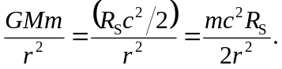

b) 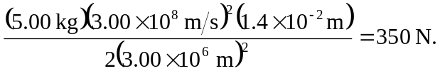

c) Solving Eq. (12.32) for 